Bahria University,

Karachi Campus



LAB EXPERIMENT NO.

**03**

LIST OF TASKS

|  |  |
| --- | --- |
| TASK NO | OBJECTIVE |
| 1 | 1. Retrieve the title and publication date of books. If the publication date is NULL, display "Not available" instead. 2. Combine the author's first name and last name into a single column and display it in uppercase. 3. Find the difference in days between the current date and the hire date of employees in the "employee" table. 4. Determine the years of experience of each employee based on their hiring date. (Table: Employee, Database: Pubs). 5. Replace the substring "St" with "Street" in the authors’ addresses. 6. Show the order date and the order month for all orders in the "orders" table. 7. List the products along with their units in stock. If units in stock are NULL, display "Out of stock. 8. Display the absolute value of the difference between the units in stock and the units on order for each product. 9. Combine the first three letters of the customer's city and the first two letters of the country for each customer. 10. Use getdate() function to get system date then use datepart() function to extract month, year and date from it. 11. Use getdate() function to get system date then use day(), month() and year() functions to extract month, year and date from it |

Submitted On:

**Date: ___11-3-202**

**Exercise**

1. **Retrieve the title and publication date of books. If the publication date is NULL, display "Not available" instead.**

**Solution:**

use pubs

SELECT title, ISNULL(CONVERT(varchar, pubdate, 106), 'Not available') AS publication_date

FROM titles;

**Output:**

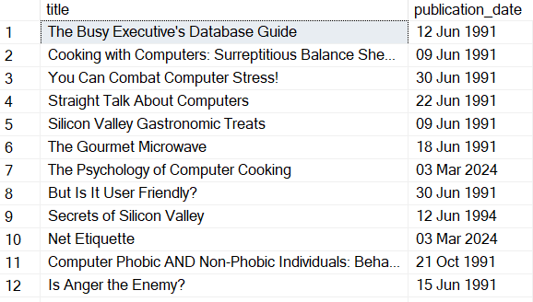

1. **Combine the author's first name and last name into a single column and display it in uppercase.**

**Solution:**

use pubs

SELECT UPPER(CONCAT(au_fname, ' ', au_lname)) AS AuthorFullName FROM authors;

**Output:**

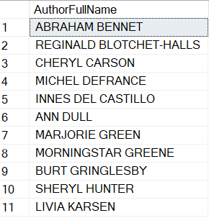

1. **Find the difference in days between the current date and the hire date of employees in the "employee" table.**

**Solution:**

use pubs

SELECT DATEDIFF(day, hire_date, GETDATE()) AS DaysSinceHired

FROM employee;

**Output:**

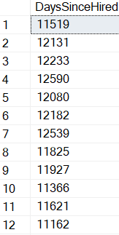

1. **Determine the years of experience of each employee based on their hiring date. (Table: Employee, Database: Pubs)**

**Solution:**

use pubs

SELECT emp_id, DATEDIFF(year, hire_date, GETDATE()) AS YearsOfExperience FROM employee;

**Output:**

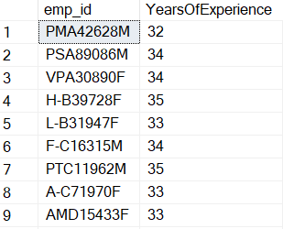

1. **Replace the substring "St" with "Street" in the authors’ addresses.**

**Solution:**

use pubs

SELECT REPLACE(address, 'St', 'Street') AS ModifiedAddress

FROM authors;

**Output:**

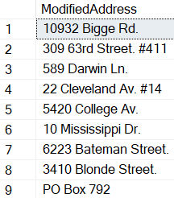

1. **Show the order date and the order month for all orders in the "orders" table.**

**Solution:**

use Northwind

SELECT OrderDate, DATEPART(month, OrderDate) AS order_month

FROM orders;

**Output:**

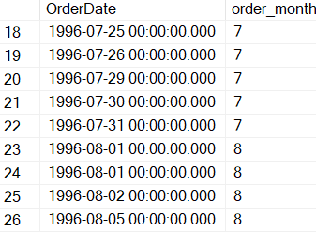

1. **List the products along with their units in stock. If units in stock are NULL, display "Out of stock.**

**Solution:**

USE Northwind;

SELECT ProductName, COALESCE(UnitsInStock,'Out of stock')

[Stock available] FROM Products;

**Output:**

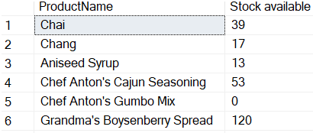

1. **Display the absolute value of the difference between the units in stock and the units on order for each product.**

**Solution:**

use Northwind

SELECT ProductName, ABS(UnitsInStock - UnitsOnOrder) AS difference

FROM products;

**Output:**

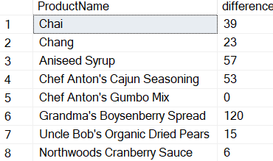

1. **Combine the first three letters of the customer's city and the first two letters of the country for each customer.**

**Solution:**

use Northwind

SELECT CONCAT(LEFT(city, 3), LEFT(country, 2)) AS CountryCode

FROM customers;

**Output:**

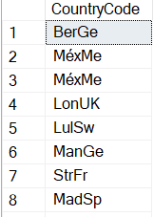

1. **Use getdate() function to get system date then use datepart() function to extract month, year and date from it.**

**Solution:**

SELECT DATEPART(day, GETDATE()) AS CurrentDay,

DATEPART(month, GETDATE()) AS CurrentMonth,

DATEPART(year, GETDATE()) AS CurrentYear;

**Output:**



1. **Use getdate() function to get system date then use day(), month() and year() functions to extract month, year and date from it.**

**Solution:**

SELECT DAY(GETDATE()) AS CurrentDay,

MONTH(GETDATE()) AS CurrentMonth,

YEAR(GETDATE()) AS CurrentYear;

**Output:**

